# Image Correlation Implementation

## 1. Harris Corner Detection

* **Code Implementations**:
* i) OpenCV:



* ii) Scratch: (use .ppm image)



* **Learning Resources:**
* i) [**OpenCV: Harris Corner Detection**](https://docs.opencv.org/4.x/dc/d0d/tutorial_py_features_harris.html)
* ii) [**Corner Detection | Edge Detection**](https://www.youtube.com/watch?v=Z_HwkG90Yvw)

**Results:  
**

## 2. SIFT (Scale-Invariant Feature Transform)

* **Code Implementations:**
* i) OpenCV:



* **Learning Resources:**
* i) [**OpenCV: Introduction to SIFT (Scale-Invariant Feature Transform)**](https://docs.opencv.org/4.x/da/df5/tutorial_py_sift_intro.html)
* ii) [**SIFT Descriptor | SIFT Detector**](https://www.youtube.com/watch?v=IBcsS8_gPzE)

**

## 3. MuDIC Library

* **Code Implementations:**
* i) Basic Algorithm and Plotting:



* ii) Using FFT:



* **Learning Resources:**
* [Chap-5] Image Correlation for Shape, Motion and Deformation Measurements (page:98–134):



* [Spline-Functions] Image Correlation for Shape, Motion and Deformation Measurements:



* Subset-based Local vs Finite Element-based Global Digital Image:



* [**[DIC/DVC/TPT] Training session 1: Digital Image/Volume Correlation (2021)**](https://www.youtube.com/watch?v=peKLXj_2W3w)
* **Results:**A close-up of a mountain

  AI-generated content may be incorrect.

## 4. autoRIFT (!! Has too many issues )

**Code:**

* [**autoRIFT/docs/demo.md at main · nasa-jpl/autoRIFT**](https://github.com/nasa-jpl/autoRIFT/blob/main/docs/demo.md) (to be called from the command-line/bash)
* **Learning Resources:**
* i) Autonomous Repeat Image Feature Tracking (autoRIFT) and Its Application for Tracking Ice Displacement:



* ii) SAR Offset Tracking Based on Feature Points:



## 5. Sentinel-1 Toolbox (SNAP)

* **Software Usage Guide:**
* [**Polarimetric Tutorial**](https://step.esa.int/docs/tutorials/S1TBX%20Offset%20Tracking%20Tutorial.pdf)
* <https://www.youtube.com/watch?v=s7QzI2YEEJU>
* **Results:**   
   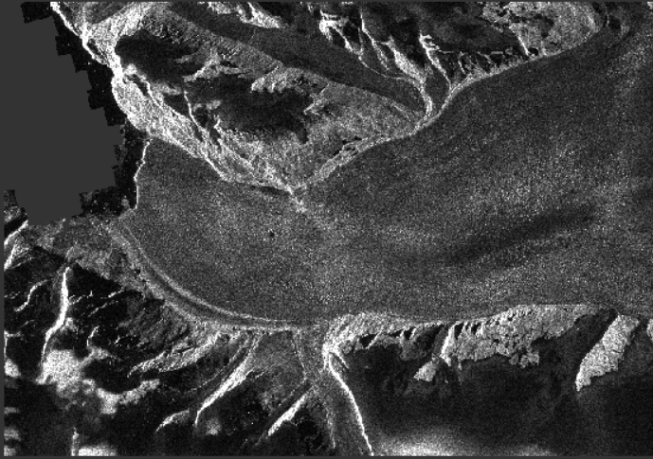 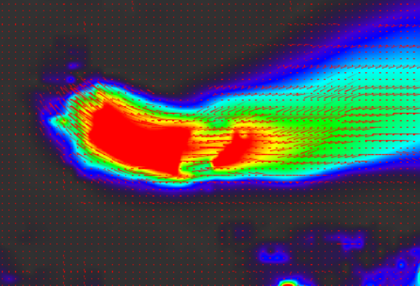
* **Velocity values for given points,**   
  